

VIETNAMESE STUDY SYSTEM FOR JAPANESE

Screen Design

**Project Code: Veazy**

**Document Code: Veazy_Screen_Design_v1.5**

**Ha Noi, 26/06/2016**

Record of change

*A - Added M - Modified D – Deleted

|  |  |  |  |  |
| --- | --- | --- | --- | --- |
| **Effective Date** | **Changed Items** | **A* M, D** | **Change Description** | **New Version** |
| 06/10/2016 | Screen design | A | Add screens | v1.0 |
| 06/30/2016 | Screen design | M | Update screens | v1.1 |
| 07/05/2016 | Screen design | M | upddate screens | v1.2 |
| 07/25/2016 | Screen design | M | Update screens | v1.3 |
| 07/20/2016 | Screen design | M | Update screens | V1.4 |
| 08/01/2016 | Screen design | M | Update screens | V1.5 |

Table 1. Records of changes

**Signature page**

**Originator** Nguyen Hong Quan 26/06/2016

Developer

**Reviewer** Nguyen Trong Duy 27/06/2016

Developer

**Approval** Nguyen Van Sang 27/06/2016

Supervisor

Contents

1 Introduction 5

1.1 Purpose 5

1.2 Definitions, Acronyms and Abbreviations 5

1.3 Overview 6

2 Screen Flow 7

2.1 Guest 9

2.1.1 Homepage 9

2.1.2 Login 11

2.1.3 Password Recover 12

2.1.4 Register 13

2.1.5 Courses 15

2.1.6 Lesson 16

2.1.7 Test 18

2.1.8 Taking Test 19

2.1.9 Test Result 20

2.2 Logged-in user 21

2.2.1 User Profile 21

2.2.2 User Statistic 22

2.3 Content creator 23

2.3.1 Content Creator Dashboard 23

2.3.2 Lesson List 25

2.3.3 Lesson Detail 26

2.3.4 Adding Lesson 28

2.3.5 Editing Lesson 30

2.3.6 Question List 31

2.3.7 Question Detail 32

2.3.8 Adding Question 34

2.3.9 Editing Question 38

2.4 Admin 42

2.4.1 Admin Dashboard 42

2.4.2 Member List 43

2.4.3 System Statistic 44

3 Other considerations 45

# Introduction

## Purpose

The purpose of this document is to ensure the consistency as well as the simplicity in detailed design across all displays within Veazy interface. Screen design describes the process of designing layout and appearance of Veazy web page so that it is engaging to readers and easy to use.

## Definitions, Acronyms and Abbreviations

|  |  |  |
| --- | --- | --- |
| Abbreviations | Description | Comment |
| Veazy | Vietnamese Study System for Japanese |  |
|  |  |  |

Table 1. Acronyms & Abbreviations

## Overview

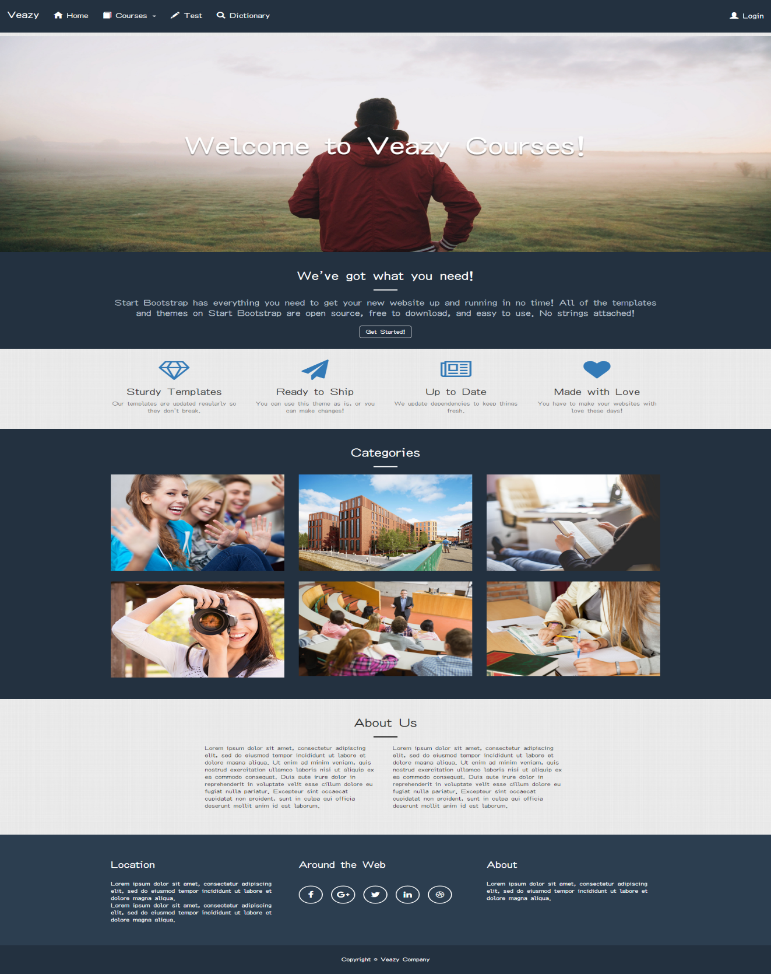

Figure 1 Homepage

# Screen Flow

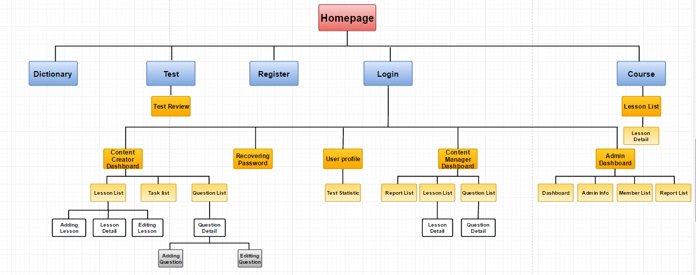

Figure 2. Screen Flow

|  |  |  |
| --- | --- | --- |
| No | Screen Name | Description |
| 1 | Homepage | Homepage |
| 2 | Login | Logging into Veazy system with a registered account |
| 3 | Register | Registering new account |
| 4 | Dictionary |  |
| 5 | Password Recover | Recovering lost password |
| 6 | Courses | Displaying list of courses and available lessons in each course |
| 7 | Lesson | Displaying lesson content |
| 8 | Test | Setting up test |
| 9 | Taking Test | Doing test |
| 10 | Test Result | Display result of test |
| 11 | User Profile | Displaying detailed information of user and statistics |
| 13 | Content Manager Dashboard |  |
| 14 | Content Creator Dashboard |  |
| 15 | Task List |  |
| 16 | Lesson List (for content manager & content creator) | Displaying lesson list |
| 17 | Lesson Detail (for content manager & content creator) | Displaying lesson detail |
| 18 | Adding Lesson | Creating new lesson |
| 19 | Editing Lesson | Editing lesson content |
| 20 | Question List | Displaying list of questions intended to be generated in test |
| 21 | Question Detail | Displaying question content |
| 22 | Adding Question | Creating new question |
| 23 | Editing Question | Editing question content |
| 24 | Admin Dashboard |  |
| 25 | Admin Infor |  |
| 26 | Member List | Displaying list of Veazy members |
| 27 | Report List | Displaying report sent by Veazy members |

Table 2. List of screens

## Guest

### Homepage



Figure 3. “Home” page

|  |  |  |  |  |  |
| --- | --- | --- | --- | --- | --- |
| **Field name** | **Type** | **Mandatory** | **Min**  **length** | **Max**  **length** | **Description** |
| Veazy | Hyperlink | N |  |  | Hyperlink that redirects to “Home” page |
| Home | Hyperlink | N |  |  | Hyperlink that redirects to “Home” page |
| Courses | Select box | N |  |  | Select box that redirects to “Courses” page |
| Test | Hyperlink | N |  |  | Hyperlink that redirects to “Test” page |
| Dictionary | Hyperlink | N |  |  | Hyperlink that redirects to “Dictionary” page |
| Login | Hyperlink | N |  |  | Hyperlink that redirects to “Login” page |
| Register | Hyperlink | N |  |  | Hyperlink that redirects to “Register” page |

Table 3. Components of “Home” page

### Login

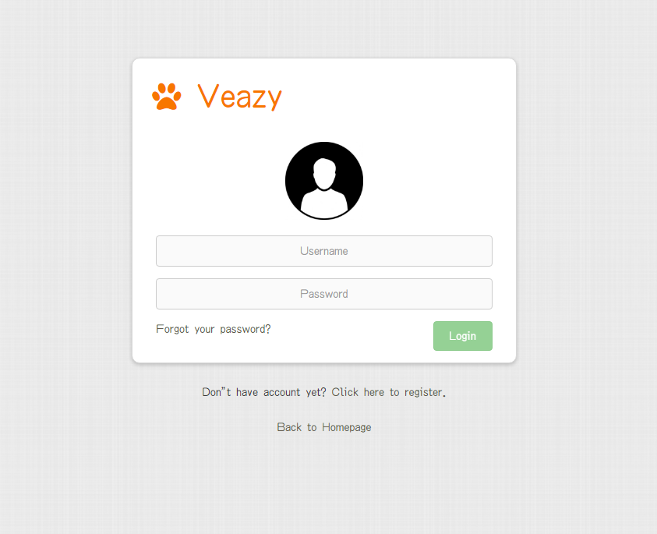

Figure 4. Login page

|  |  |  |  |  |  |
| --- | --- | --- | --- | --- | --- |
| **Field name** | **Type** | **Mandatory** | **Min**  **length** | **Max**  **length** | **Description** |
| Username | Textbox | Y | 6 | 30 | Textbox for entering username |
| Password | Textbox | Y | 6 | 32 | Textbox for entering password |
| Login | Button | Y |  |  | Button for submitting login form |
| Forgot your password? | Hyperlink | N |  |  | Hyperlink that redirects to “Password Recover” page |
| Click here to register. | Hyperlink | N |  |  | Hyperlink that redirects to “Register” page |
| Back to Home | Hyperlink | N |  |  | Hyperlink that redirects to “Home” page |

Table 4. Components of “Login” page

### Password Recover

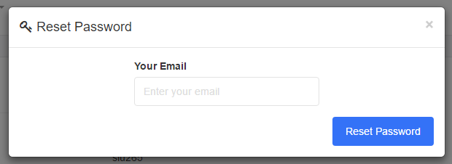

Figure 5. “Password Recover” page

|  |  |  |  |  |  |
| --- | --- | --- | --- | --- | --- |
| **Field name** | **Type** | **Mandatory** | **Min**  **length** | **Max**  **length** | **Description** |
| Email | Textbox | Y | 6 | 254 | Textbox for entering the email linked with current account |
| Reset password | Button | Y |  |  | Button for submitting email |

Table 5. Components of “Password Recover” page

### Register

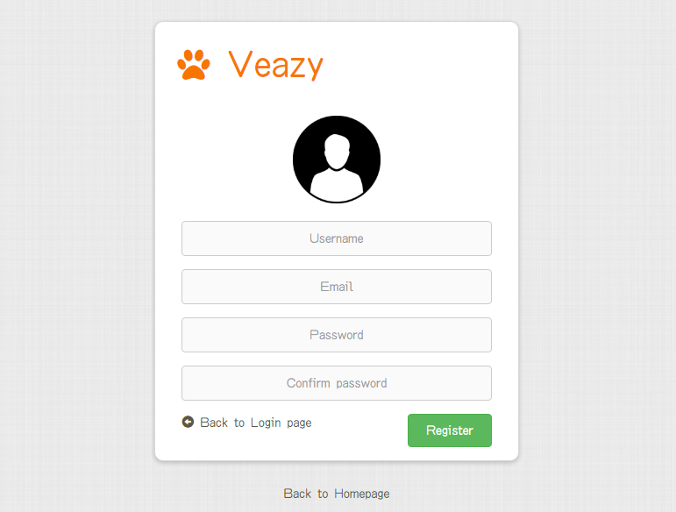

Figure 6. “Register” page

|  |  |  |  |  |  |  |  |
| --- | --- | --- | --- | --- | --- | --- | --- |
| **No** | **Field name** | **Type** | **Require** | **Mandatory** | **Min**  **length** | **Max**  **length** | **Description** |
| 1 | Username | Textbox | Input | Y | 8 | 30 | Textbox for entering username |
| 2 | Email | Textbox | Input | Y | 6 | 254 | Textbox for entering email |
| 3 | Password | Textbox | Input | Y | 8 | 32 | Textbox for entering password |
| 4 | Confirm Password | Textbox | Input | Y | 8 | 32 | Textbox for re-entering password |
| 5 | Register | Button | Click | Y |  |  | Button to submit register form |
| 6 | Back to Login page | Hyperlink | Click | N |  |  | Hyperlink that redirects to “Login” page |
| 7 | Back to Homepage | Hyperlink | Click | N |  |  | Hyperlink that redirects to “Home” page |

Table 6. Components of “Register” page

### Courses

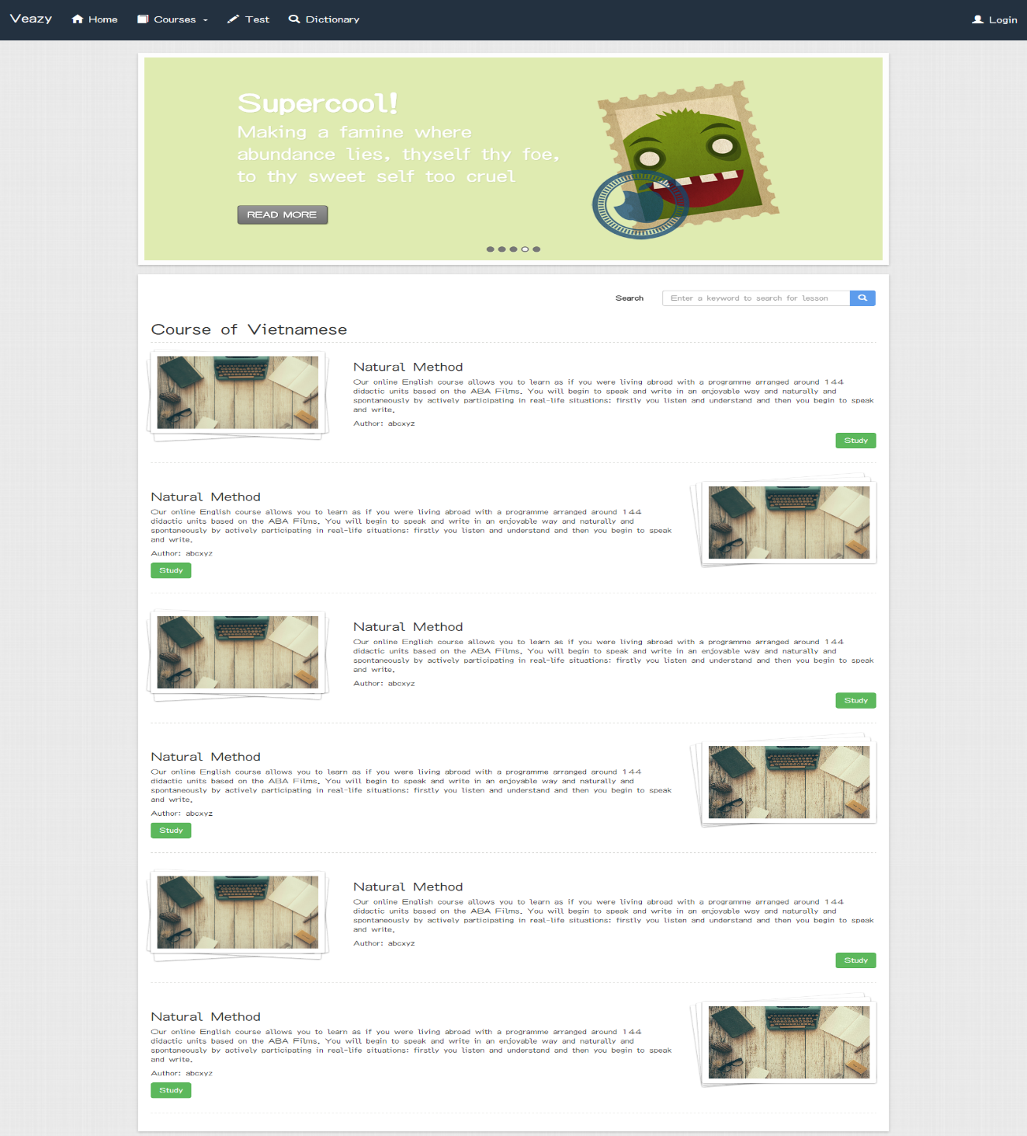

Figure 7. “Courses” page

|  |  |  |  |  |  |
| --- | --- | --- | --- | --- | --- |
| **Field name** | **Type** | **Mandatory** | **Min**  **length** | **Max**  **length** | **Description** |
| Search | Text |  |  |  | Textbox for entering a keyword to search for lessons whose content contains the keyword |
| Search | Button |  |  |  | Button for submitting search keyword |
| Study | Button |  |  |  | Button that redirects to “Lesson” page |

Table 7. Course page’s components

### Lesson

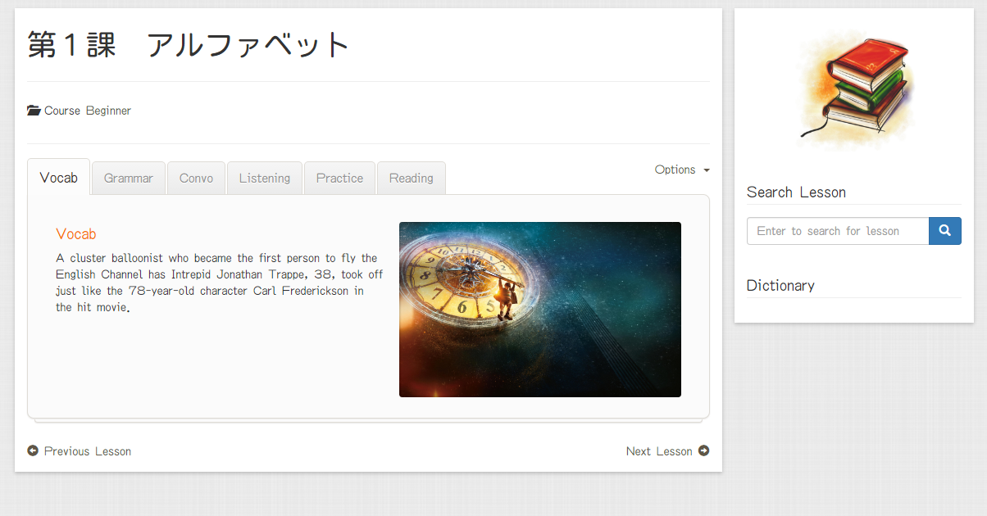

Figure 8. “Lesson Detail” page

|  |  |  |  |  |  |
| --- | --- | --- | --- | --- | --- |
| **Field name** | **Type** | **Mandatory** | **Min**  **length** | **Max**  **length** | **Description** |
| Vocab | Hyperlink | N |  |  | Hyperlink that displays content of Vocabulary section |
| Grammar | Hyperlink | N |  |  | Hyperlink that displays content of Grammar section |
| Convo | Hyperlink | N |  |  | Hyperlink that displays content of Conversation section |
| Listening | Hyperlink | N |  |  | Hyperlink that displays content of Listening section |
| Practice | Hyperlink | N |  |  | Hyperlink that displays content of Practice section |
| Reading | Hyperlink | N |  |  | Hyperlink that displays content of Reading section |
| Previous lesson | Hyperlink | N |  |  | Hyperlink that redirects to “Lesson” page which displays content of the previous lesson |
| Next lesson | Hyperlink | N |  |  | Hyperlink that redirects to “Lesson” page which displays content of the next lesson |
| Search lesson | Textbox | N |  |  | Textbox for entering a keyword to search for lesson whose content contains the keyword |
| Search lesson | Button | N |  |  | Button for submitting search keyword |
| Option | Hyperlink | N |  |  | Hyperlink to display selectable options |
| Report | Hyperlink | N |  |  | Hyperlink to display lesson report dialog |

Table 8. Components of “Lesson” page

### Test

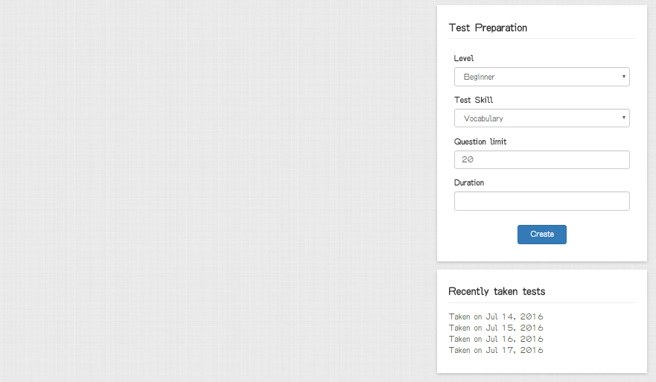

Figure 9. “Test” page

|  |  |  |  |  |  |
| --- | --- | --- | --- | --- | --- |
| **Field name** | **Type** | **Mandatory** | **Min**  **length** | **Max**  **length** | **Description** |
| Level | Select box | Y |  |  | Select box for selecting difficulty level of test |
| Test Skill | Select box | Y |  |  | Select box for selecting skill to be tested |
| Question Limit | Number | Y |  |  | Textbox for entering the number of questions |
| Duration | Text | Y |  |  | User inputs duration of test |
| Create | Button | Y |  |  | Button for submitting test setup form and redirecting to “Take Test” page |
| Test History | Hyperlink | N |  |  | Hyperlink for redirecting to “Test result” page which displays the taken test result  (Only available if user logged in) |

Table 9. Components of “Test” page

### Taking Test

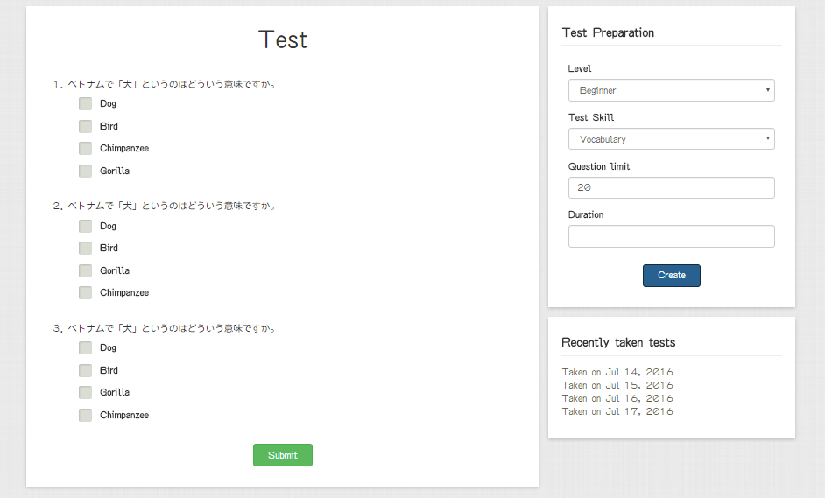

Figure 10. “Taking Test” page

|  |  |  |  |  |  |
| --- | --- | --- | --- | --- | --- |
| **Field name** | **Require** | **Mandatory** | **Min**  **length** | **Max**  **length** | **Description** |
| Answer | Click | Y |  |  | Radio button for choosing the correct answer |
| Submit | Click | Y |  |  | Button for submitting the test and redirecting to “Test Result” page |

Table 10. Components of “Taking Test” page

### Test Result

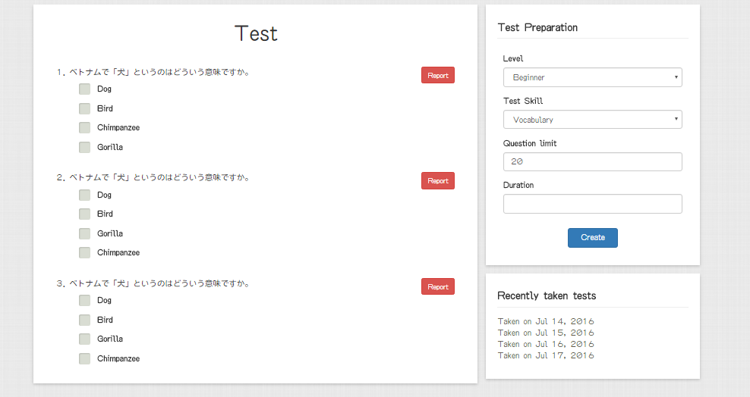

Figure 11. “Test Result” page

|  |  |  |  |  |  |
| --- | --- | --- | --- | --- | --- |
| **Field name** | **Type** | **Mandatory** | **Min**  **length** | **Max**  **length** | **Description** |
| Report | Button | Y |  |  | Button for submitting report about questions that user subjectively consider wrong content. |

Table 11. Components of “Test Result” page

## Logged-in user

### User Profile

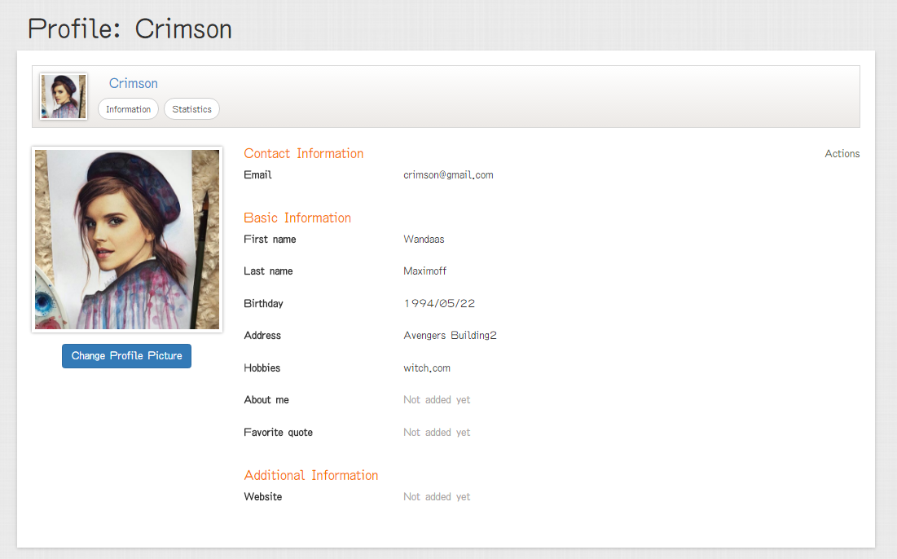

Figure 12. “User Profile” page

|  |  |  |  |  |  |
| --- | --- | --- | --- | --- | --- |
| **Field name** | **Type** | **Mandatory** | **Min**  **length** | **Max**  **length** | **Description** |
| Action | Dropdown | N |  |  | Dropdown that displays selectable options for user include editing information and changing current password |
| Information | Hyperlink | N |  |  | Hyperlink that displays tab for viewing user information |
| Change Avatar Picture | Button | N |  |  | Hyperlink that displays dialog for changing current avatar picture |
| Statistic | Hyperlink | N |  |  | Hyperlink that displays tab for viewing user statistics |

Table 12. Components of “User Profile” page

### User Statistic

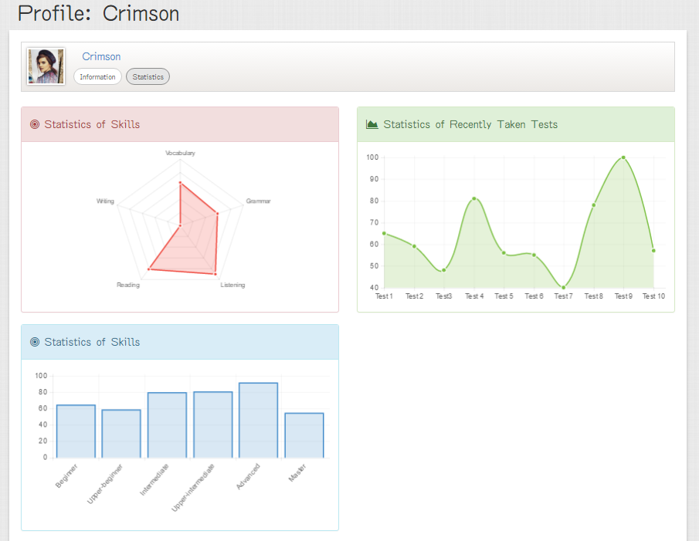

Figure 13. “User Statistic” page

|  |  |  |  |  |  |
| --- | --- | --- | --- | --- | --- |
| **Field name** | **Type** | **Mandatory** | **Min**  **length** | **Max**  **length** | **Description** |
| Information | Hyperlink | N |  |  | Hyperlink that displays tab for viewing user information |
| Statistic | Hyperlink | N |  |  | Hyperlink that displays tab for viewing user statistics |

Table 13. Components of “User Statistic” page

## Content creator

### Content Creator Dashboard

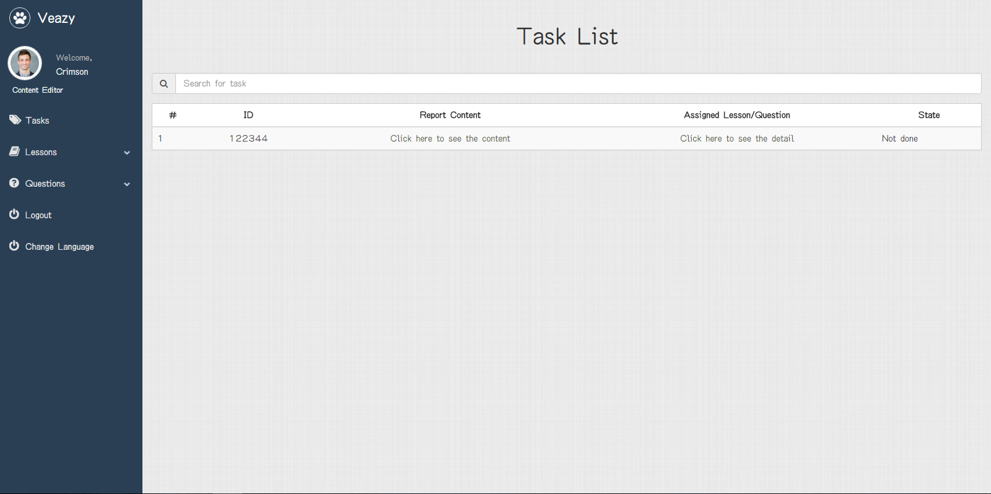

Figure 14. “Content Creator Dashboard” page

|  |  |  |  |  |  |
| --- | --- | --- | --- | --- | --- |
| **Field name** | **Type** | **Mandatory** | **Min**  **length** | **Max**  **length** | **Description** |
| Lessons | Hyperlink | N |  |  | Hyperlink that opens lesson management menu |
| Lesson List | Hyperlink | N |  |  | Hyperlink that redirects to “Lesson List” page |
| Add Lesson | Hyperlink | N |  |  | Hyperlink that redirects to “Adding Lesson” page |
| Question | Hyperlink | N |  |  | Hyperlink that opens question management menu |
| Question List | Hyperlink | N |  |  | Hyperlink that redirects to “Question List” page |
| Add Question | Hyperlink | N |  |  | Hyperlink that redirects to “Adding Question” page |
| Tasks | Hyperlink | N |  |  | Hyperlink that redirects to “Tasks” page |
| Logout | Hyperlink | N |  |  | Hyperlink that logs user out of Veazy system |
| Click here to see content | Hyperlink | N |  |  | Hyperlink that showing content of report |
| Click here to see the details | Hyperlink | N |  |  | Hyperlink that showing detail content of lesson or question |

Figure 14. Components of “Content Creator Dashboard”

### Lesson List

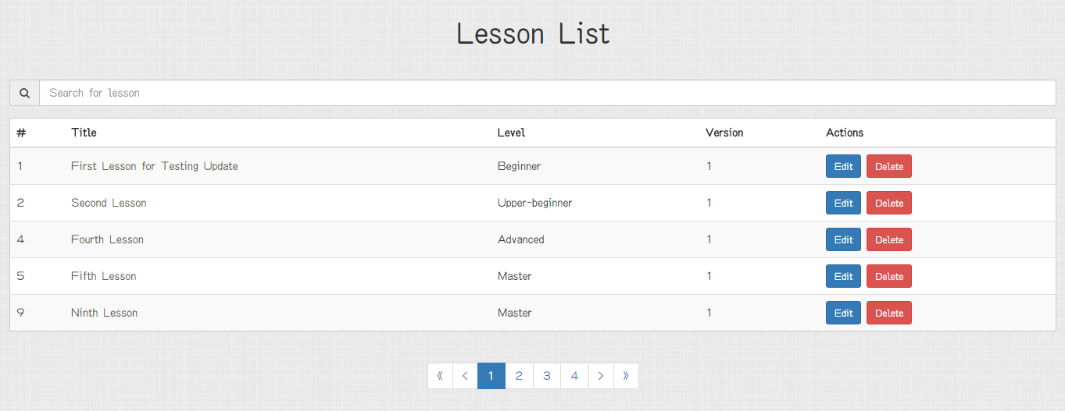

Figure 15. “Lesson List” page

|  |  |  |  |  |  |
| --- | --- | --- | --- | --- | --- |
| **Field name** | **Type** | **Mandatory** | **Min**  **length** | **Max**  **length** | **Description** |
| Lesson title | Hyperlink | N |  |  | Hyperlink that redirects to “Lesson Detail” page |
| Edit | Button | N |  |  | Hyperlink that redirects to “Editing Lesson” page |
| Delete | Button | N |  |  | Button for deleting corresponding lesson |
| << | Button | N |  |  | Button for displaying the first 5 lessons in table |
| < | Button | N |  |  | Button for navigating to 5 previous lessons in table |
| > | Button | N |  |  | Button for navigating to 5 next lessons in table |
| >> | Button | N |  |  | Button for navigating to 5 last lessons in table |
| Search | Textbox | N |  |  | Textbox for entering keyword and displaying lessons whose content contains the keyword |

Figure 15. Components of “Lesson List”

### Lesson Detail

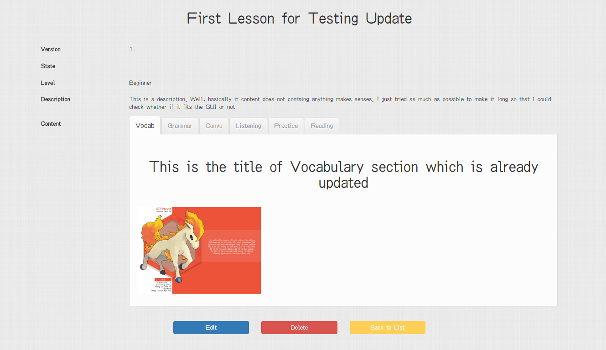

Figure 16. “Lesson List” page

|  |  |  |  |  |  |
| --- | --- | --- | --- | --- | --- |
| **Field name** | **Type** | **Mandatory** | **Min**  **length** | **Max**  **length** | **Description** |
| Vocab | Hyperlink | N |  |  | Hyperlink that displays content of Vocabulary section |
| Grammar | Hyperlink | N |  |  | Hyperlink that displays content of Grammar section |
| Convo | Hyperlink | N |  |  | Hyperlink that displays content of Conversation section |
| Listening | Hyperlink | N |  |  | Hyperlink that displays content of Listening section |
| Practice | Hyperlink | N |  |  | Hyperlink that displays content of Practice section |
| Reading | Hyperlink | N |  |  | Hyperlink that displays content of Reading section |
| Edit | Button | N |  |  | Hyperlink that redirects to “Editing Lesson” page |
| Delete | Button | N |  |  | Button for deleting corresponding lesson |
| Back to list | Textbox | N |  |  | Button for redirects to “Lesson List” page |

Figure 16. Components of “Lesson Detail”

### Adding Lesson

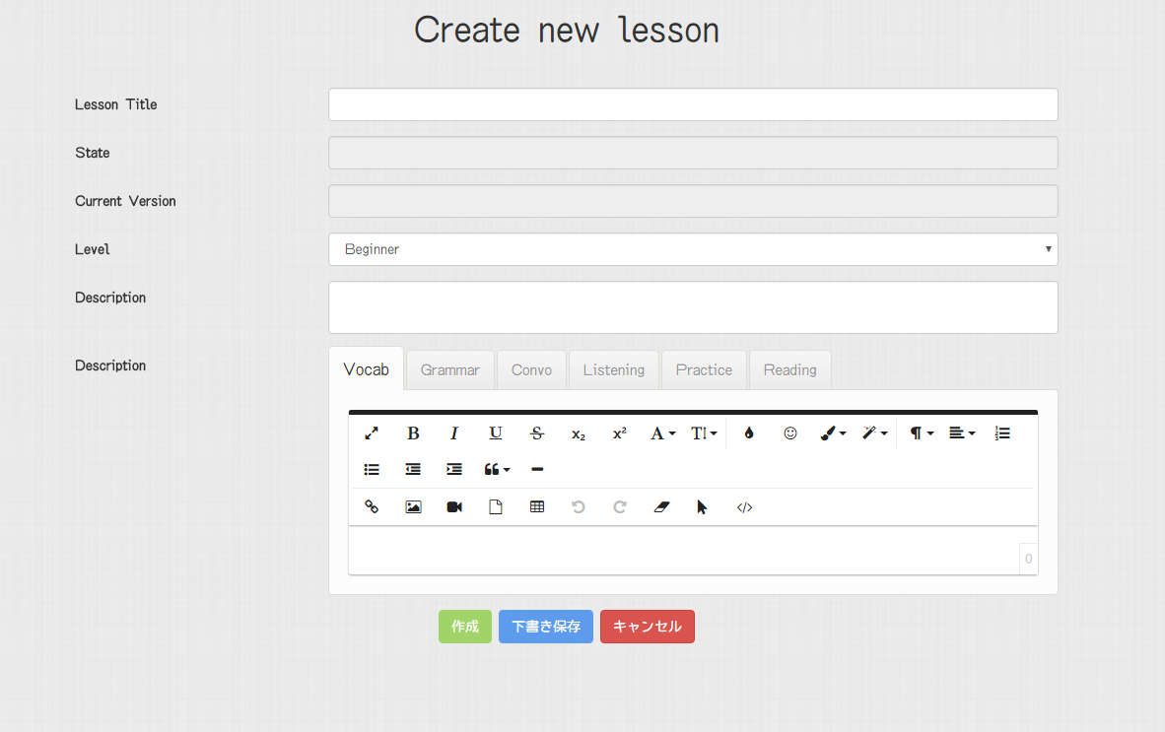

Figure 17. “Adding Lesson” page

|  |  |  |  |  |  |
| --- | --- | --- | --- | --- | --- |
| **Field name** | **Type** | **Mandatory** | **Min**  **length** | **Max**  **length** | **Description** |
| Lesson Title | Text | Y | 0 |  | Textbox for entering lesson title |
| State | Text | Y |  |  | Textbox that displays current state of lesson |
| Current Version | Text | Y |  |  | Textbox that displays current version number of lesson |
| Level | Select box | Y |  |  | Select box for choosing difficulty level of lesson |
| Description | Text area | Y |  |  | Text area for entering lesson description |
| Vocab | Hyperlink | Y |  |  | Hyperlink that displays editor of Vocabulary section |
| Text area | Y |  |  | Text area for entering content of Vocabulary section |
| Grammar | Hyperlink | Y |  |  | Hyperlink that displays editor of Grammar section |
| Text area | Y |  |  | Text area for entering content of Grammar section |
| Convo | Hyperlink | Y |  |  | Hyperlink that displays editor of Conversation section |
| Text area | Y |  |  | Text area for entering content of Conversation section |
| Listening | Hyperlink | Y |  |  | Hyperlink that displays editor of Listening section |
| Text area | Y |  |  | Text area for entering content of Listening section |
| Practice | Hyperlink | Y |  |  | Hyperlink that displays editor of Practice section |
| Text area | Y |  |  | Text area for entering content of Practice section |
| Reading | Hyperlink | Y |  |  | Hyperlink that displays editor of Reading section |
| Text area | Y |  |  | Text area for entering content of Reading section |
| Create | Button | Y |  |  | Button for submitting new lesson |
| Save draft | Button | N |  |  | Button for saving entered content as draft so that it can be re-opened next time |
| Cancel | Button | N |  |  | Button for cancelling creating new lesson |

Table 17. Components of “Adding Lesson” page

### Editing Lesson

Figure 18. “Editing Lesson” page

|  |  |  |  |  |  |
| --- | --- | --- | --- | --- | --- |
| **Field name** | **Type** | **Mandatory** | **Min**  **length** | **Max**  **length** | **Description** |
|  |  |  |  |  |  |
|  |  |  |  |  |  |
|  |  |  |  |  |  |
|  |  |  |  |  |  |

Table 18. Components of “Editting Lesson” page

### Question List

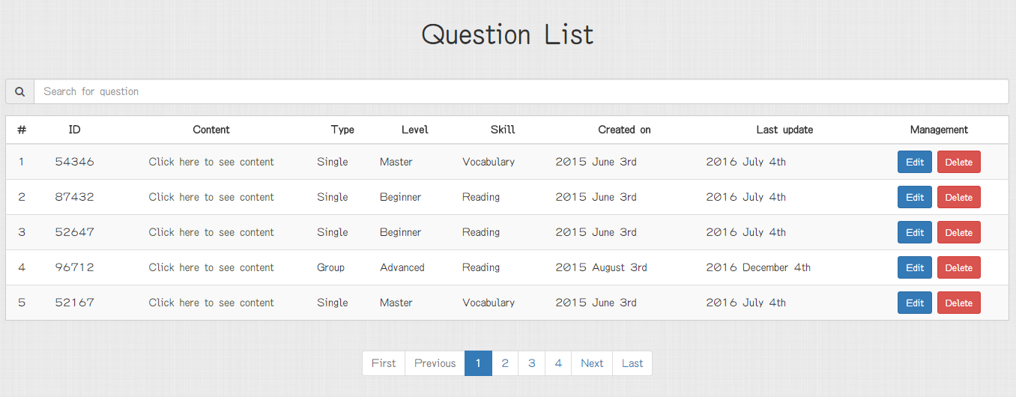

Figure 19. “Question List” page

|  |  |  |  |  |  |
| --- | --- | --- | --- | --- | --- |
| **Field name** | **Type** | **Mandatory** | **Min**  **length** | **Max**  **length** | **Description** |
| Click here to see content | Hyperlink | N |  |  | Hyperlink that redirects to “Question Detail” page |
| Edit | Button | N |  |  | Hyperlink that redirects to “Editing Question” page |
| Delete | Button | N |  |  | Button for deleting corresponding question |
| First | Button | N |  |  | Button for displaying the first 5 questions in table |
| Previous | Button | N |  |  | Button for navigating to 5 previous questions in table |
| Next | Button | N |  |  | Button for navigating to 5 next records in table |
| Last | Button | N |  |  | Button for navigating to 5 last questions in table |
| Search | Textbox | N |  |  | Textbox for entering keyword and displaying questions whose content contains the keyword |

Table 19. Components of “Question List page

### Question Detail

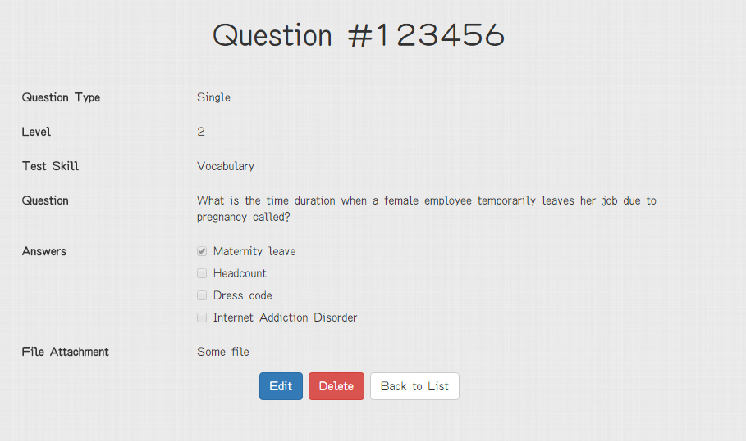

Figure 20. “Question Detail” page (single question)

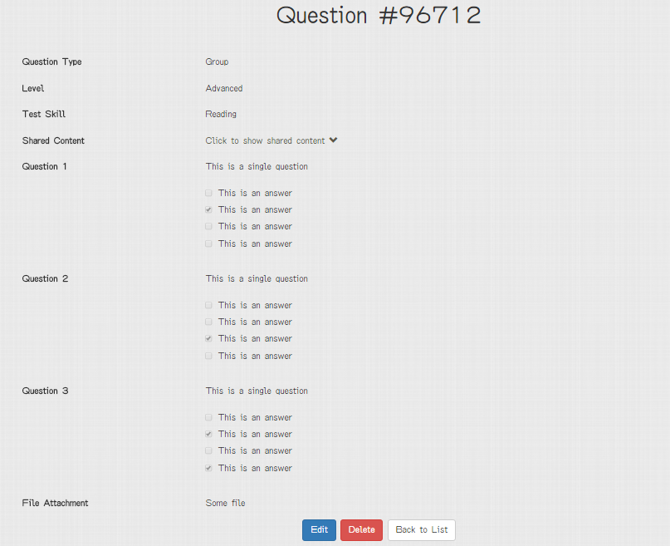

Figure 21. “Question Detail” page (group question)

|  |  |  |  |  |  |
| --- | --- | --- | --- | --- | --- |
| **Field name** | **Type** | **Mandatory** | **Min**  **length** | **Max**  **length** | **Description** |
| Click to show shared content | Hyperlink |  |  |  | Hyperlink that displays shared content of group question |
| Edit | Button | N |  |  | Button that redirects to “Editing Question” page |
| Back | Button | N |  |  | Button that redirects back to “Question List” page |
| Delete | Button | N |  |  | Button for deleting question |

Table 20. Components of “Question Detail” page

### Adding Question

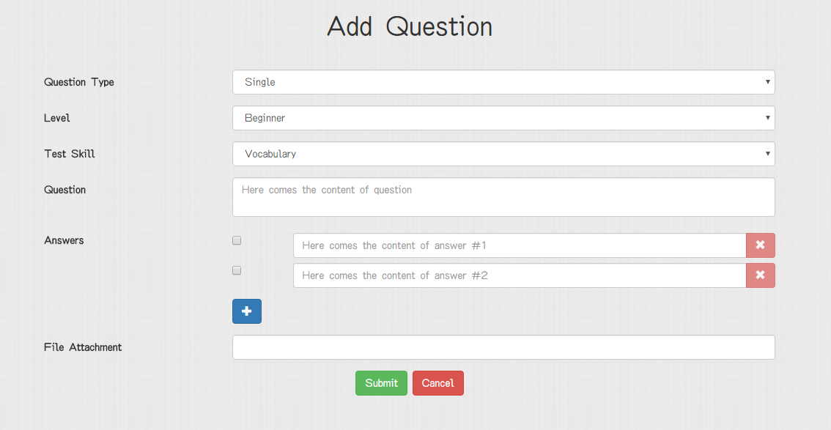

Figure 22. “Adding Question” page (single question)

|  |  |  |  |  |  |
| --- | --- | --- | --- | --- | --- |
| **Field name** | **Type** | **Mandatory** | **Min**  **length** | **Max**  **length** | **Description** |
| Question type | Select box | Y |  |  | Select box for choosing type of question |
| Level | Select box | Y |  |  | Select box for choosing difficulty level of question |
| Test Skill | Select box | Y |  |  | Select box for choosing skill to be tested of question |
| Question | Text | Y |  |  | Textbox for entering question |
| Check box | Check box | Y |  |  | Checkbox for marking which answer is true |
| Answer | Text | Y |  |  | Textbox for entering answer content |
| X | Button | N |  |  | Button for removing an answer |
| + | Button | N |  |  | Button for adding one more answer to the question |
| File attachment | File | N |  |  |  |
| Submit | Button | Y |  |  | Button for submitting new question |
| Cancel | Button | N |  |  | Button for cancelling adding new question and redirecting back to “Question List” page |

Table 21. Components of “Adding Question” page (single question)

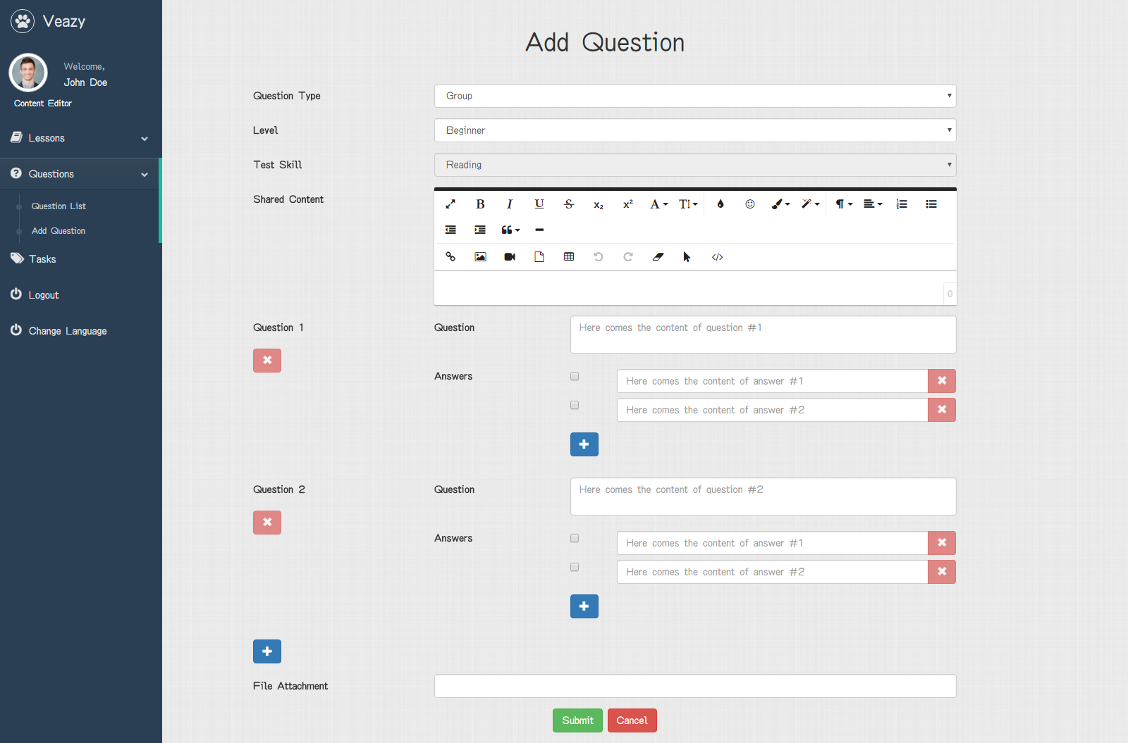

Figure 23. “Adding Question” page (group question)

|  |  |  |  |  |  |
| --- | --- | --- | --- | --- | --- |
| **Field name** | **Type** | **Mandatory** | **Min**  **length** | **Max**  **length** | **Description** |
| Question type | Select box | Y |  |  | Select box for choosing type of question |
| Level | Select box | Y |  |  | Select box for choosing difficulty level of question |
| Test Skill | Select box | Y |  |  | Select box for choosing skill to be tested of question |
| Shared content | Text area | Y |  |  | Text area for entering shared content of group question |
| Question | Textbox | Y |  |  | Textbox for entering content of question in group |
| X | Button | N |  |  | Button for removing question in group |
| Check box | Check box | Y |  |  | Checkbox that marks the correct answer in question |
| Answer | Textbox | Y |  |  | Textbox for entering content of answer |
| X | Button | Y |  |  | Button for removing answer in question |
| + | Button | N |  |  | Button for adding one more answer |
| File attachment | File | N |  |  |  |
| Submit | Button | Y |  |  | Button for submitting new question |
| Cancel | Button | Y |  |  | Button for cancelling adding new question and redirecting back to “Question List” page |

Table 22. Components of “Adding Question” page (group question)

### Editing Question



Figure 24. “Editing Question” page (single question) (1)

|  |  |  |  |  |  |
| --- | --- | --- | --- | --- | --- |
| **Field name** | **Type** | **Mandatory** | **Min**  **length** | **Max**  **length** | **Description** |
| Question type | Select box | Y |  |  | User selects the type of question to be edited |
| Level | Select box | Y |  |  | User selects difficulty level of the question |
| Test Skill | Select box | Y |  |  | User selects the skill of question |
| Question | Textbox | Y |  |  | User inputs question content |
| Check box | Check box | Y |  |  | User clicks to decide the correct answer(s) |
| Answer | Textbox | Y |  |  | User inputs contents of selectable answers of a question |
| + | Button | N |  |  | User clicks button to add more selectable answers of the question. |
| File attachment | File | N |  |  | User clicks to choose file and upload |
| Submit | Button | Y |  |  | User clicks to submit the question content |
| Cancel | Button | N |  |  | User clicks to go back to Questions List page |

Table 23. Components of “Editing Question” page (single question) (1)



Figure 25. “Editing Question” page (group question) (2)

|  |  |  |  |  |  |  |  |
| --- | --- | --- | --- | --- | --- | --- | --- |
| **No** | **Field name** | **Type** | **Require** | **Mandatory** | **Min**  **length** | **Max**  **length** | **Description** |
| 1 | Question type | Select box | Select | Y |  |  | User selects the type of question to be added |
| 2 | Level | Select box | Select | Y |  |  | User selects difficulty level of question |
| 3 | Test Skill | Select box | Select | Y |  |  | User selects the skill of question |
| 4 | Shared content | Text | Input | Y |  |  | User inputs the shared content used by all questions |
| 5 | Question | Text | Input | Y |  |  | User inputs content of a single question in group |
| 6 | X | Button | Click | N |  |  | User clicks to remove the corresponding question in group |
| 7 | Check box | Check box | Click | Y |  |  | User clicks to decide the correct answer(s) |
| 8 | Answer | Text | Input | Y |  |  | User inputs answer content of each question |
| 9 | X | Button | Click | Y |  |  | User clicks to remove the corresponding answer |
| 10 | + | Button | Click | N |  |  | User clicks to add more question to the group |
| 11 | File attachment | File | Upload | N |  |  | User clicks to choose file and upload |
| 12 | Submit | Button | Click | Y |  |  | User clicks to submit the group question |
| 13 | Cancel | Button | Click | Y |  |  | User clicks to cancel adding and return to Questions List page |

Table 24. Components of “Editing Question” page (group question)(2)

## Admin

### Admin Dashboard

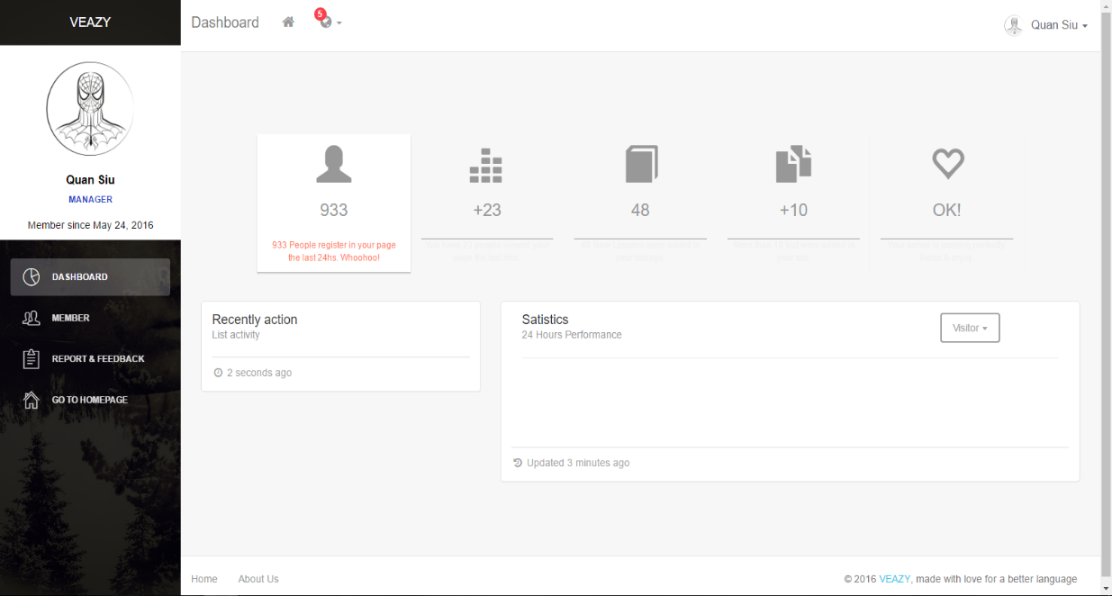

Figure 26. “Admin Dashboard” page

|  |  |  |  |  |  |  |  |
| --- | --- | --- | --- | --- | --- | --- | --- |
| **No** | **Field name** | **Type** | **Require** | **Mandatory** | **Min**  **length** | **Max**  **length** | **Description** |
| 1 | Member | Hyperlink | Click | N |  |  | User clicks to navigate to Member List page |
| 2 | Report & Feedback | Hyperlink | Click | N |  |  | User clicks to display list of reports & feedbacks |

Table 25. Components of “Admin Dashboard” page

### Member List

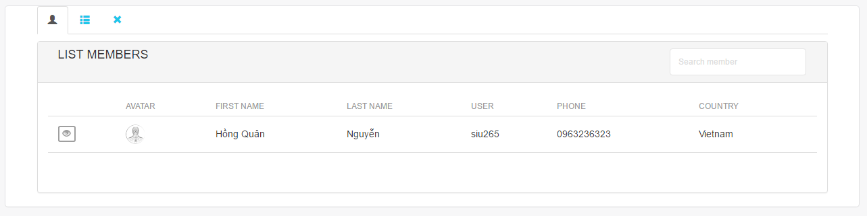

Figure 27. “Member List” page

|  |  |  |  |  |  |  |  |
| --- | --- | --- | --- | --- | --- | --- | --- |
| **No** | **Field name** | **Type** | **Require** | **Mandatory** | **Min**  **length** | **Max**  **length** | **Description** |
| 1 | Member list | Tab | Click | N |  |  | User clicks to display member list |
| 2 | Member list by role | Tab | Click | N |  |  | User clicks to display member list with respective roles |
| 3 | Banned member list | Tab | Click | N |  |  | User clicks to display banned member list |
| 4 | View detail | Button | Click | N |  |  | User clicks to display detailed inTypeion of members |
| 5 | Search member | Text | Input | N |  |  | User inputs a keyword to search |

Table 26. Components of “Member List” page

### System Statistic

Figure 28. “System Statistic” page

|  |  |  |  |  |  |  |  |
| --- | --- | --- | --- | --- | --- | --- | --- |
| **No** | **Field name** | **Type** | **Require** | **Mandatory** | **Min**  **length** | **Max**  **length** | **Description** |
|  |  |  |  |  |  |  |  |
|  |  |  |  |  |  |  |  |
|  |  |  |  |  |  |  |  |
|  |  |  |  |  |  |  |  |
|  |  |  |  |  |  |  |  |

Table 27. Components of “System Statistic” page

# Other considerations

**N/A**